FRP No. ___________________

LET’S SERVE HUMANITY

SUBMITTED BY

1. M. ABDULLAH WASEEM (SP17-bSSE-0060)

2. SHEIKH HARIS KHALID (SP17-bSSE-0046)

SUPERVISED BY

Mr. Munim Ali Khan



FYP REPORT SUBMITTED TO THE FACULTY OF COMPUTER SCIENCES, MOHAMMAD ALI JINNAH UNIVERSITY, IN PARTIAL FULFILMENT OF THE REQUIREMENTS FOR THE DEGREE OF BACHELOR OF SOFTWARE ENGINEERING/COMPUTER SCIENCE

FALL 2020

**LET’S SERVE HUMANITY**

**Batch Spring – 2017**

DEPARTMENT OF COMPUTER SCIENCE

Mohammad Ali Jinnah University, Karachi

January 2021

# Preface

Final year projects have importance and impact on student’s life. We from the beginning wanted to select a project that can benefit society. We both were a part of an NGO named Let’s Serve Humanity (LSH), initiated by students at Mohammad Ali Jinnah University. LSH aims to look after the needs of common people that cannot afford the things for marriage, school/college/university fees, need of blood, warm clothes, etc. We both decided to select it for our Final Year Project as more people will come to know about it through this platform. There are many technologies available, but we wanted to build a mobile application as it is most common nowadays. We selected React native for this purpose. It was a challenge for both of us first to learn it and then implement it the way we want.

# Acknowledgment

We would like to express our deep gratitude to Munim Ali Khan our mentor and final year project supervisor, for his patient advice, passionate encouragement, assistance in maintaining our progress on time, and useful critiques of this project. His commitment to give his time so big-heartedly has been very much appreciated. ­­­­

We sincerely believe that our report is up to the mentor’s expectations. The time spent when making this report has managed to have prepared us with the abilities and expertise that we did not know earlier. This will help us and will also turn out to be a great benefit for our professional life soon.

We would also like to extend our appreciation to the operators of the laboratory of the Computer Science department for their support in presenting us with the resources in operating the system.

**Introduction to group members** 

M. Abdullah Waseem SP17-BSSE-0060

(Mobile Application, Server, Database, Dashboard)   
Immediate Contact: ([abdwaseem1998@gmail.com](mailto:abdwaseem1998@gmail.comK), +92 305 2065888)

Sheikh Haris Khalid SP17-BSSE-0046   
(Mobile Application, Database, Server, Dashboard)

Immediate Contact: ([hariskhalid.14@gmail.com](mailto:hariskhalid.14@gmail.com), +92 334 1235334)

# CERTIFICATE OF COMPLETION

**This is to certify that the following students of BS (CS/SE) of Batch Spring 2017**

M. Abdullah Waseem SP17-BSSE-0060

Sheikh Haris Khalid

SP17-BSSE-0046

**have successfully completed their final year project titled.**

**LET’S SERVE HUMANITY**

**In the partial fulfillment for the Degree of Bachelor of Science in Computer Science/ Software Engineering.**

**Mr. Munim Ali Khan**

Lecturer

Mohammad Ali Jinnah University

# Abstract

As we know there are a lot of people that are in need, but they do not want to ask for help from anyone. Those are the deserving ones and should be helped upon. But how can we help them if we do not know their needs? This problem can be solved through our LSH platform, an individual can post a case according to their needs and requirements, it will be anonymous and only the LSH team will know about the name of the user as they must verify the case. Upon verification, the case will be uploaded on the mobile application and the users can donate it accordingly. The details of the donor will not be given to anyone else except the LSH team. The management team of LSH will keep a record of how many users have donated for a case and how much amount is gathered. We often help someone and think that we have bought them and ask for favors from them again and again. The best part of this platform is that both the donor and the needy person will not know about each other.

There is a dashboard for the management team of LSH from where they can keep the record of all users and in case of difficulty they can be contacted upon.

Contents

Preface iii

Acknowledgment iv

CERTIFICATE OF COMPLETION vi

Abstract vii

CHAPTER 1 12

INTRODUCTION 12

1.1. Overview 12

1.2. Objective 12

1.3. Problem Statement 12

1.4. Project Scope 13

1.5. Intended audience and reading suggestions 13

1.6. References 14

CHAPTER 2 15

Literature Review 15

CHAPTER 3 16

Tools & technologies 16

3.1. Visual studio 16

3.2. React native 16

3.3. Angular js 16

3.4. Node js 16

3.5. Mongo db 17

3.6. Stripe 17

CHAPTER 4 18

overall description 18

4.1. Product perspective 18

4.2. product features 18

4.2.1 FOR DONORS: 18

4.2.2 NEEDY PEOPLE: 18

4.2.3 THE MANAGEMENT TEAM OF LSH: 19

4.3. user classes and characteristics 19

4.4. Operating environment 19

4.5. design and implementation constraints 19

4.6. User documentation 20

4.7. Assumptions and dependencies 20

4.8. System features 21

4.8.1. SYSTEM FEATURES 21

4.8.2. FUNCTIONAL REQUIREMENTS 21

4.9. Use Case Diagram 22

4.9.1 USE CASE: SEE DETAILS 23

4.9.2 USE CASE: DONATE 24

4.10 external interface requirements 25

4.10.1 USER INTERFACES 25

4.10.2 HARDWARE INTERFACES 25

4.10.3 SOFTWARE INTERFACES 25

4.10.4 COMMUNICATIONS INTERFACES 25

4.11. Non-Functional Requirements 25

4.11.1 USABILITY REQUIREMENTS 25

4.11.2. SECURITY REQUIREMENTS 26

4.11.3. EXTERNAL REQUIREMENTS 26

4.11.4. PERFORMANCE REQUIREMENTS 26

4.11.5. ORGANIZATIONAL REQUIREMENTS 26

4.11.6. OPERATIONAL REQUIREMENTS 26

4.11.7. DEVELOPMENT REQUIREMENTS 26

4.11.8. ETHICAL REQUIREMENTS 26

4.11.9. REGULATORY REQUIREMENTS 27

4.11.10 SOFTWARE QUALITY ATTRIBUTES 27

4.12 Operational Requirements 27

4.12.1 PERFORMANCE REQUIREMENTS 27

4.12.2 SAFETY REQUIREMENTS 27

4.12.3 SECURITY REQUIREMENTS 27

4.12.4 TESTABILITY REQUIREMENTS 27

4.13 Other Requirements 27

4.13.1 AVAILABILITY 27

4.13.2 INSATIABILITY 28

4.13.3 INTEGRITY 28

CHAPTER 5 29

System Design 29

5.1. UML Class Diagram 29

5.2. State Diagram 30

5.3. Activity Diagram 30

5.4. Evaluation of prototype: 31

CHAPTER 6 32

System Implementation 32

6.1. Needy person 32

6.2. For Donors 33

6.3. Management team of lsh (admin) 34

6.4. Other screens 36

6.5. Payment Dashboard 39

CHAPTER 7 41

Testing 41

7.1. Graphical User Interface Testing 41

7.2. Usability Testing 41

7.3. Software Performance Testing 41

7.4. Compatibility testing 42

7.5. Exception Handling Testing 42

7.6. Load Testing 42

7.7. Test Cases 42

FUTURE SCOPE 50

appendix a: Mockups 51

Appendix b: gantt chart 54

# CHAPTER 1

## INTRODUCTION

## 1.1. Overview

This project has been taken by experiencing the difficulties faced by the people while searching for the needy peoples. A lot of people who are willing to help the needy people are unable to distinguish them which is the main problem. Also, some needy people need help, but they do not know what to do and who to contact. If we talk only about Karachi there are a lot of people who need help, be it financial or any other form, but they are being a common man, so their voice is not raised to the concerned authorities.

## 1.2. Objective

Some of the issues faced by the public are:

* To decide which person is needier.
* Waiting for the right person to donate.
* Have doubts whether the donated item is handed over to the right person or not.

Our application LET’S SERVE HUMANITY is creating a medium between the needy people and the ones who are willing to donate. If the project becomes successful, our goal to serve humanity will be fulfilled.

## 1.3. Problem Statement

Wherever we see if any problem is highlighted through social media it catches everyone’s attention and the problem is solved. But many other problems are not highlighted, there are a lot of people who want to help others. But they do not get the platform from where they can help others. It is not only about money, but more than that. It can be helping a student financially in studies, providing clothes, or blood. People sometimes only help the people who are from their community only and are not willing to help others want to build an application that can be used by everyone and not only a community, cast, religion. There will be no discrimination against any sect.

## 1.4. Project Scope

Some applications are running around but again if an application already exists does not mean that it is perfect, nothing is perfect. There are some flaws that we identified in those applications that are:

* Some applications only had a list of categories with no detail of cases.
* While some applications had the cases but no progress of how things are going and what is the result in the end.

We have three categories for people to donate these are Donation, Sadaqat, and Zakat. We of course will utilize the donation based on their categories while keeping in mind our religious beliefs. There are certain elements that we will look upon our priority will be solely based upon the seasons. Most of the cases related to fees of the students come around 2 times of the year, Spring and Fall. So, at this time our focus will be on gathering students’ fees and helping them in their studies. Most of the weddings take place 2 times a year, June-July, and Nov-Dec season. In these 2 seasons, our priority will be to look after the wedding expenses of people who cannot afford it. If we mentioned the priority it does not mean that at this time we will not look after any other cases in this duration. We will take care of all cases but first, our focus is on completing the high priority cases.

## 1.5. Intended audience and reading suggestions

This project targets all the audience that includes both males and females that finds it difficult to arrange money for weddings, for school fees, with the age of above 15. And they should have a facility of internet available.

* Donors (who will donate the money through this application)
* Needy People (Those people who need help)
* The management team of LSH/Admin (who can give and update the details of the cases daily)

## 1.6. References

This document is written by group members only as the idea of the project is original so there was no need to add a reference to other authors or publishers.

# CHAPTER 2

## Literature Review

There has been an increase in people begging around the city for a few years. We tend to see many street beggars stopping people around and asking for help daily. On the other hand, they also went door to door holding prescriptions and medical reports in their hands and even carry patients with them.

The beggar mafia has now become one of the major problems. If we stop at a traffic signal for some time, we can see one or few street beggars (most of the time it is a woman carrying an infant or a disabled child) who begs and asks for help. People here often get confused as to whether if they are going to give zakat or any other donations to someone really in need or not. So, to help such people in making sure, that their donations are not going into the hands of those begging and receiving donations as a part of their business (mafia), this mobile application will be anonymous, it will not disclose the name of the user who wants help, and the one who will be helping him.

# CHAPTER 3

## Tools & technologies

* Visual Studio
* React Native (Frontend)
* Angular JS (Admin)
* Node.js (Backend)
* MongoDB (NoSQL Database)
* Stripe (Payment Gateway)

## 3.1. Visual studio

It is used for the development of computer projects and programs, mobile applications, web applications, single-page applications. The software uses various languages like C++, C++/CLI, and Visual Basic .NET, C#, and F #, JavaScript, Typescript, XML,

XSLT, HTML and CSS.

## 3.2. React native

It is an open-source framework developed by Facebook and it is used for designing and developing mobile applications and web applications of Android, IOS, Web applications, etc.

## 3.3. Angular js

It is a front-end framework designed and controlled by Google. It provides a framework for Model View Controller and Model View, View Model frameworks. It is used in MEAN Stack, which consists of Mongo DB framework, Express, and Node js Server.

## 3.4. Node js

It is an open-source backend cross-platform framework used for server-side scripting. It is more used by real-time web applications for server and client-side.

## 3.5. Mongo db

Mongo DB is a no SQL database. Mongo DB uses JSON documents. It is more common with real-time web and mobile applications as the requirements are not still and keeps changing. Mongo DB provides updating and flexibility in designing the database.

## 3.6. Stripe

Stripe is a payment gateway used for accepting payments, testing APIs, mostly related to eCommerce web and mobile applications.

# CHAPTER 4

## overall description

## 4.1. Product perspective

This mobile application can be used by all the registered users, such that it is creating a medium between the needy people and the ones who are willing to donate and the management staff of the LSH team. Registered Users can upload a case according to its needs by filling in the required details and others can donate by select the payment methods and case. Data will be stored in a database from where the management team of Let’s Serve Humanity will use the database to add, modify, and delete data.

## 4.2. product features

### 4.2.1 FOR DONORS:

* Donors need to create their accounts if they want to use the application for donations.
* Donors can find the cases on the front page based on the priority.
* Donors can review the amount given for any case.
* Donors can donate in more than one category and cases also.
* Donors can also select the category in which they have to donate their money.
* Donors can contact the management team and give feedback on the application.
* Donors can see the target amount, collected amount, and the time duration of the case.

### 4.2.2 NEEDY PEOPLE:

* Needy people need to create their accounts if they want to upload a case.
* Needy people can post a case according to their needs.
* Needy people will fill a form that includes the details about the case.
* Needy people can contact the management team of LSH using the application.
* The management team can give guidance if needy people find any difficulty.

### 4.2.3 THE MANAGEMENT TEAM OF LSH:

* The management team will receive the form filled by needy people.
* The management team can track the status of a case and keep updating it.
* The management team can verify the case and decide to approve or reject the case.
* The management team can arrange the cases based on their priority on the home screen.
* The management team can verify the cases of needy people before approving or rejecting any case and only the approved cases appear on the home screen.
* The management team can record donors and donate to each case.

## 4.3. user classes and characteristics

Two types of users will be using this system. One is donors and the other one is needy people. Both donors and needy people will use this mobile application. Donors can use this application to see the details of any case and to donate money for it also will be able to donate casually. The Needy People can use this application to give the details of its needs so that donors can see it and help those who are in need.

## 4.4. Operating environment

This system is operating on the web portal. This system will interact with the server and the database. The server operates on a windows 10 operating system with 40 GB ram and 100 TB storage. The data is stored using Mongo DB (database).

## 4.5. design and implementation constraints

* There can be various constraints for both mobile applicants and web users.
* Mobile applicants can face application malfunctions depending on their mobile type since this app requires internet or Wi-Fi connection, many people might not have this facility, the internet is not always or everywhere available, this might limit its effectiveness.
* Web-users might also face the problem. Internet downfall can cause my progress to slack.
* Not all systems are well built, some are of new technology while some are still old, the old systems have a slow response time.

## 4.6. User documentation

The mobile application will facilitate the client’s side by side when they will be performing actions. They will be trained by tutorials that will help them operate the system.

## 4.7. Assumptions and dependencies

The application will provide 24hr details to the donors and the management of LSH if the internet is available. The product will always be used on mobile phones that have enough hardware resources available. A mobile application can face application malfunctions depending on their mobile type since the app requires the internet and it may not be available every time. Internet downfall can cause my progress to slack. Not all systems are well built; some are of new technology while the same is still old, the old systems have a slow response time. Application is dependent on ISP’s to work properly, for proper communication between components of the system and between systems themselves. Another assumption for users is that the product will always be used on mobile phones that have enough performance. If the phone does not have enough hardware resources available for the application, for example, the users might have allocated them with other applications, there may be scenarios where the application does not work as intended or even at all.

## 4.8. System features

### 4.8.1. SYSTEM FEATURES

The front of the mobile application contains approved cases.

* The front page of the mobile application which is the home page contains all the current cases which are arranged priority-wise, which is, of course, the time factor, the priority will keep on changing according to the cases and seasons.
* The home page consists of all the approved cases.
* Clicking on any case will give the detail of the case.
* Payment options (easy paisa, jazz cash, bank transfer)
* On the home page, there is an option of casual donation for the donor.
* There shall be a login system for users.
* Backend for admin: It is required for verification or update cases etc.

### 4.8.2. FUNCTIONAL REQUIREMENTS

* The donor shall be able to check the status of the cases online.
* The donor shall be able to select the categories for donation.
* The donor shall be able to review its charity given for a case.
* Needy People shall be able to post their cases through the application.
* The management team of LSH shall be able to update the cases frequently.
* The system shall be able to allow the donor/needy people to contact the management in case of difficulty.
* The management team of LSH shall be able to have a close check of cases under their supervision.
* The system shall be able to notify the management team if any malfunction occurs or any mishaps happens.
* The management team shall be able to have a close look at the system to avoid any interruptions from unauthorized users.
* The system shall be able to notify the management team when the amount required for a case is achieved.
* The system shall be able to provide ease to both, donors, and needy people to get the work done efficiently and effectively.
* The system shall be able to prevent any disruption from an external entity.
* The needy people shall be able to fill requirements form to post a case.
* The system shall be able to notify the donor if he has donated for any case.

## 4.9. Use Case Diagram

### 4.9.1 USE CASE: SEE DETAILS

|  |  |
| --- | --- |
| Description | The donor and management team can see details of the cases given by the needy person. |
| Preconditions | Needy Condition should enter its requirements. |
| Data | A needy person can fill the requirements on the form given by the admin. |
| Stimulus | A needy person clicks on submit after filling the requirement in the form. |
| Response | Admin will first verify the details and then display them on the application if verified. |
| Flow of event | * Open mobile application * The user will log in to the system. * A needy person enters the requirements on the upload case page. * Admin will verify the requirements and display them on the approved case page. * Donors can see the details of the cases. |
| Postcondition | Donors can donate money by selecting a case. |
| Comment | Needy Persons must enter the correct requirement according to their needs because it will first be verified by the management team. |

### 4.9.2 USE CASE: DONATE

|  |  |
| --- | --- |
| Description | As the cases on the home page are shown, users can see the details of the cases and then donate for them. |
| Preconditions | Donors first need to be registered and logged in to the system. |
| Data | Donors can donate casually and should first select the case and then fill in the required details (Credit card number, CNIC number, etc.) |
| Stimulus | Donor clicks on donating after filling requirements in the payment details to proceed with the payment. |
| Response | The details will be verified first and then the donor will get a message of successful payment done. |
| Flow of event | * Open mobile application * The donor will log in to the system. * The donor can casually donate by clicking the above donate button or will select a case from the home page and then donate by entering their details. * The details will be verified first and then the donor will receive a message of payment done successfully if verified. * Donors can see the donation which is collected for the case. |
| Postcondition | After the payment donors will be notified if the case is complete or still payment required if the target is not complete. |
| Comment | Donors must enter correct information because it will first be verified by the easy paisa, jazz cash, or any bank. |

## 4.10 external interface requirements

### 4.10.1 USER INTERFACES

At first, the login page will be visible to both the donor and needy people. As soon as they log in to the application the cases page will appear on the screen. The status of running cases will be shown on the screen. Users can donate, add new cases, can view the projects of the LSH team, can get to know the history of LSH.

### 4.10.2 HARDWARE INTERFACES

Mobile phones are used to run specific applications and computers interact with application servers.

### 4.10.3 SOFTWARE INTERFACES

The mobile application communicates with the application servers to get information from the database to get the information about the usage. The communication between the database and the mobile application consists of operations concerning both reading and modifying the data.

### 4.10.4 COMMUNICATIONS INTERFACES

The communication between the different parts of the system is important since they depend on each other. However, in what way the communication is achieved is not important for the system and is therefore handled by the underlying operating systems for the mobile application.

## 4.11. Non-Functional Requirements

### 4.11.1 USABILITY REQUIREMENTS

Both the management team and the donors can use this system to monitor but a donor cannot make changes in the system.

### 4.11.2. SECURITY REQUIREMENTS

The login and password of the user are required to login into the application. The data of donor/needy people is visible only to the donor/needy people and not to anyone else, in case of data being delivered to an unauthorized user, the donor/needy people will be notified.

### 4.11.3. EXTERNAL REQUIREMENTS

Those who have signed into the system will receive details, any outsider will not be permitted to access the system.

### 4.11.4. PERFORMANCE REQUIREMENTS

Those who have signed into the system will receive details, any outsider will not be permitted to access the system.

### 4.11.5. ORGANIZATIONAL REQUIREMENTS

The system should follow all the organizational norms, any functionality other than organizational norm should not be included in the system. The system should authorize specific users with limited access as it will be against organization culture to give access to personal records of donors and needy people.

### 4.11.6. OPERATIONAL REQUIREMENTS

The system is capable of handling 100 requests at a time means at one time the system is capable to perform either data entries or retrievals. Requests more than one thousand will be placed in the queue so that as soon as one user closes its operation other can continue with his own.

### 4.11.7. DEVELOPMENT REQUIREMENTS

Systems and subsystems should be developed using specific development tools and methods. Development methods other than specified ones cannot be used.

### 4.11.8. ETHICAL REQUIREMENTS

The system is well protected, it allows the needy people and donors to login and password to either see data or to access data. There are certain changes that you cannot make without certain authorizations.

### 4.11.9. REGULATORY REQUIREMENTS

The system obeys the laws of regulatory bodies and every functionality provided in systems does not exceed the limits and boundaries that are not specified by regulatory bodies.

### 4.11.10 SOFTWARE QUALITY ATTRIBUTES

The system is capable of handling 100 requests at a time means at one time the system is capable to perform either data entries or retrievals. Requests more than one thousand will be placed in the queue so that as soon as one user closes its operation other can continue with his own.

## 4.12 Operational Requirements

### 4.12.1 PERFORMANCE REQUIREMENTS

If at most 100,000 people logins into the application, it will not affect its performance.

### 4.12.2 SAFETY REQUIREMENTS

The users can enter their correct information without any fear as their no such change of any system hack or anything like that in this application.

### 4.12.3 SECURITY REQUIREMENTS

Only the users that are registered through this app can only log in to the system nonregistered users have to register first to see what is inside the system. The system is protected from viruses.

### 4.12.4 TESTABILITY REQUIREMENTS

The system is easy to test it can also be divided into different modules so that it is easier for testing.

## 4.13 Other Requirements

### 4.13.1 AVAILABILITY

The system shall be available 97% in a year and will be shut down for at least 4 hours on Sunday morning from 6 am to 9 am twice a year.

### 4.13.2 INSATIABILITY

The system shall be taken a minimum of 2 minutes on installation while the time is dependent on how fast the device will work. The maximum time taken would be 5 minutes for any amateur user.

### 4.13.3 INTEGRITY

The Bridge of information between the donor and LSH team is based on encryption so that no other person can overwrite them.

# CHAPTER 5

## System Design

## 5.1. UML Class Diagram

## 5.2. State Diagram

## 5.3. Activity Diagram

## 5.4. Evaluation of prototype:

We have to use Jacob Nielsen’s 10 principles to evaluate the prototype.

|  |  |  |
| --- | --- | --- |
| **Principles** | **Yes or No** | **Reason** |
| Visibility of the system | Yes | Each functionality is visible |
| Match between the real world | Yes | Yes, it’s like the real world |
| User Control | Yes | User can control this system |
| Consistency and standard | Consistent | All pages follow the same template |
| Error Prevention | Yes |  |
| Recognition rather than recall | No |  |
| Flexibility and efficiency of use | Yes |  |
| Aesthetic and minimalist | No aesthetic | Yes minimalist |
| Help and documentation | No | No guideline is needed |
| Recover from recognize and error | Yes |  |

# CHAPTER 6

## System Implementation

In this chapter we describe our android application and how it works and how it covers all our proposed scenarios also the internal components and how it also works the way of communication between the LSH team and donor, here our end users are a donor and the needy person.

## 6.1. Needy person

Needy people need to create their accounts if they want to upload a case after that they need to select the “Upload Case” from the drawer of the home page, then fill a form that includes the details about the case and click on “Submit”. After the submission, the management team of LSH decides through the verification to approve the case or to reject the case. If the case was approved, it will be present on the home screen and if the case was rejected it will be discarded. In both cases, the needy person notifies about the decision made by the management team of Let’s Server Humanity.

## 6.2. For Donors

Donors need to create their accounts if they want to use the application for donations. There are two different ways to donate.

The first one is related to specific with the case donation. Hereafter the log in the donor needs to select any approved case which is listed on the home screen. Click the “Donate” button to proceed, it will be directed to the donate screen where the donor clicks on “Bank Transfer”, then fill a bank transfer form that includes the details about the donation and click on “Submit”. The second one is a direct donation which is not related to any specific case and the amount is used on any case depend on the situation and need, this decision is taken by the management team of Let’s Server Humanity.

## 6.3. Management team of lsh (admin)

* The management team will receive the form filled by needy people.
* The management team can track the status of a case and keep updating it.

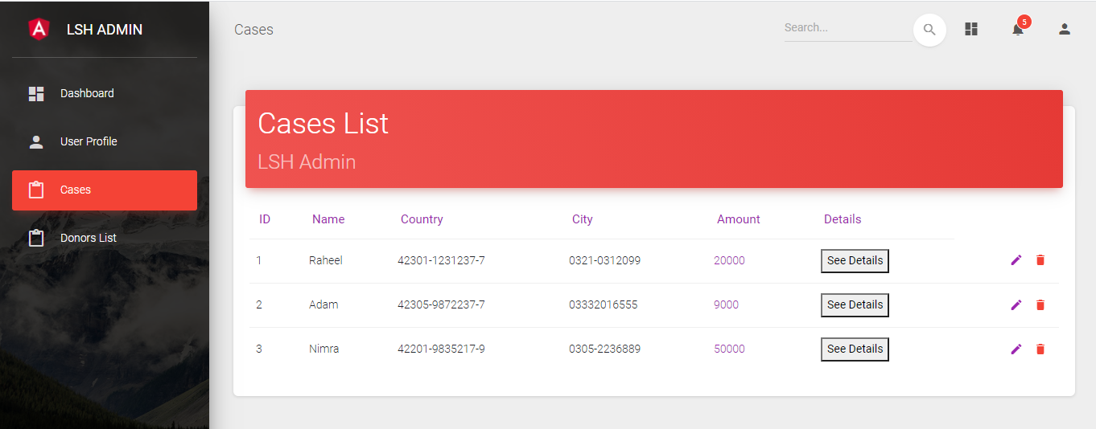

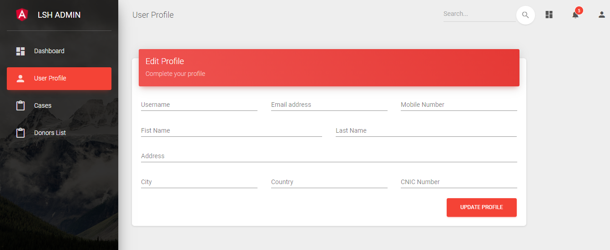

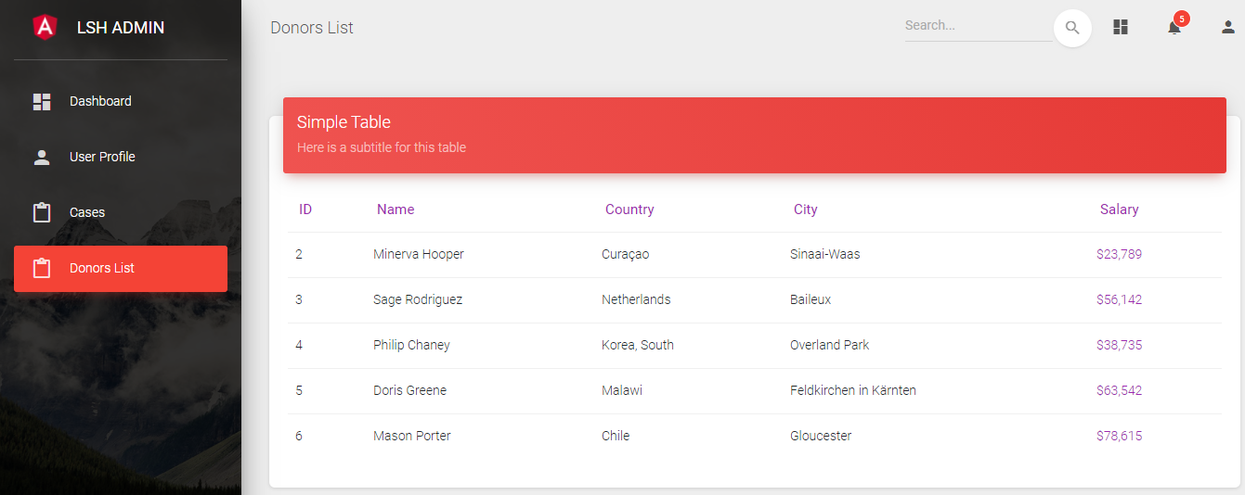

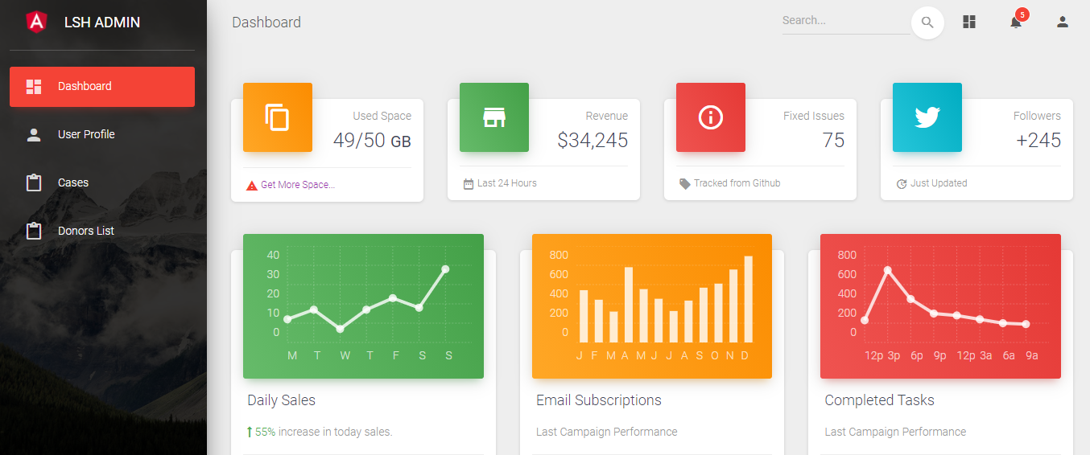

## 6.4. Other screens

## 6.5. Payment Dashboard

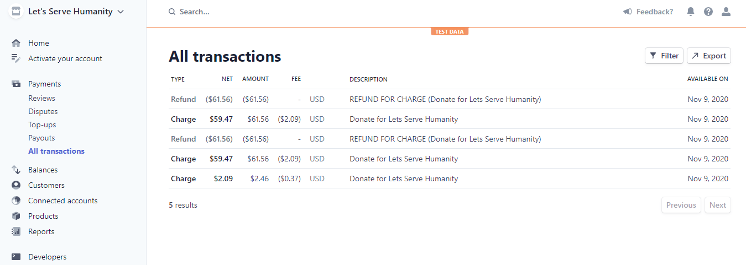

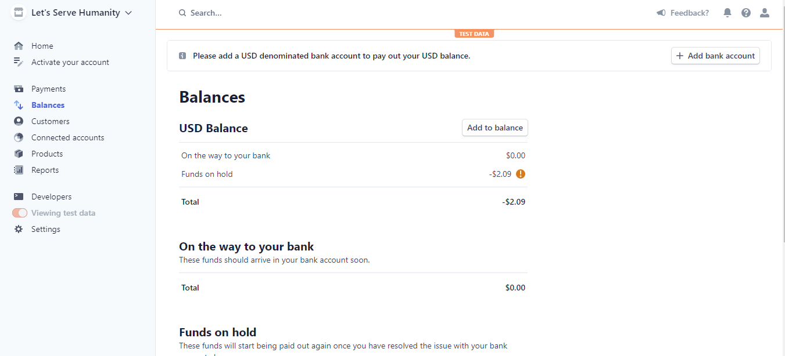

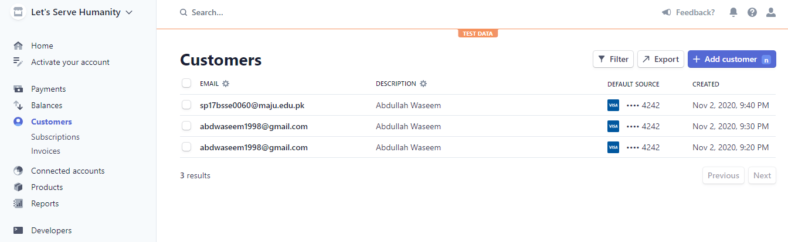

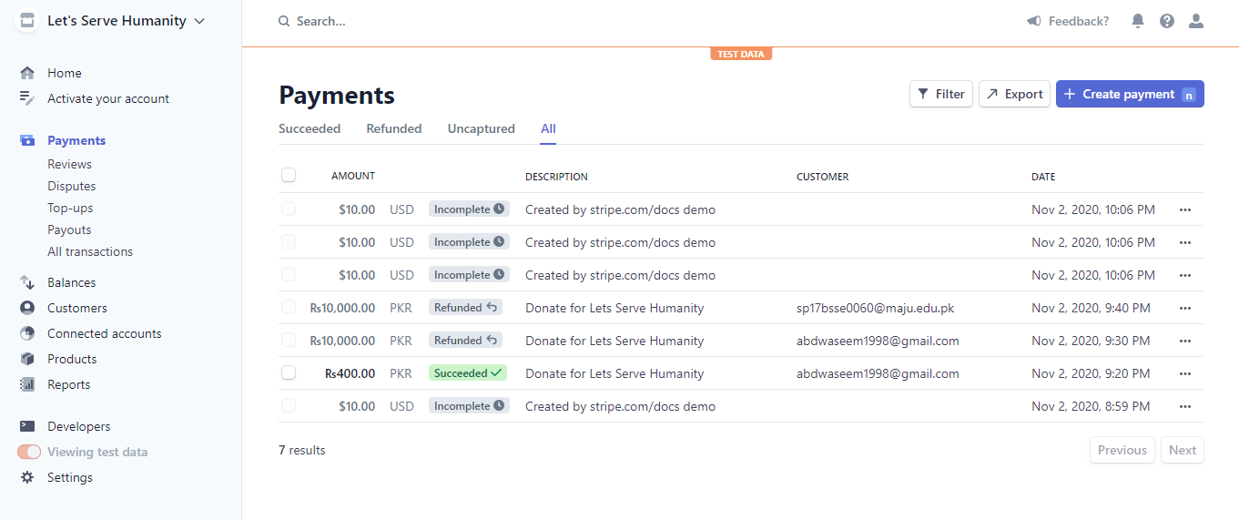

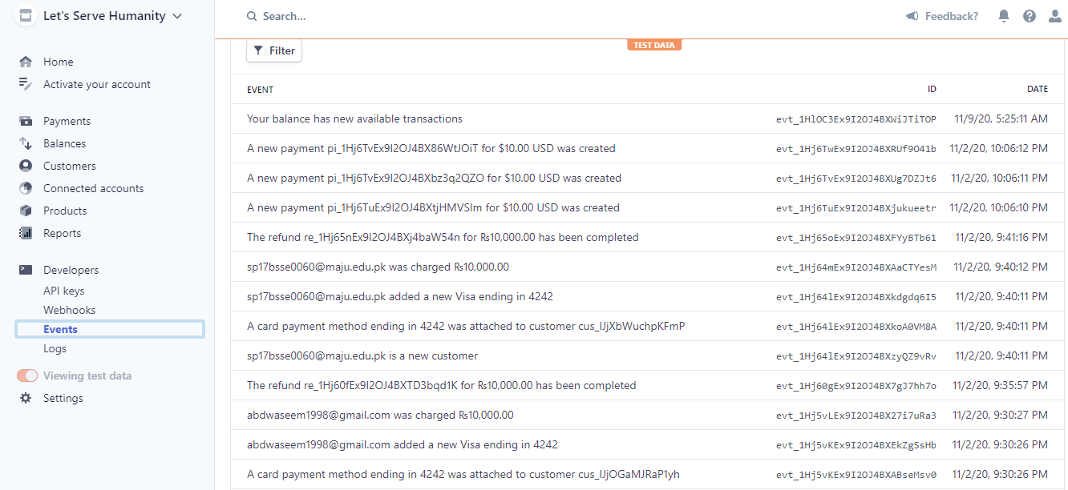

# CHAPTER 7

## Testing

Test cases are the mirror of the actual milestones of requirements met. That is why in this stage we look further to test the features functionally of the application in such a way that no component of the application collapses or goes into an unambiguous state. The procedure of testing the application is well clarified in a way that tester can effectively execute his job. In this period of testing, every test case is not about a Win-win situation but occasionally about Win or Lose position also when a certain action is done as an input. Below are some test cases that have been performed and which also verifies what has been established up to the mark and is according to prerequisites collected during the prerequisite gathering period.

## 7.1. Graphical User Interface Testing

GUI testing is a way to check the user interface of the application as to how the device elements are presented to the users. GUI testing includes screen checking with the controls such as menus, buttons, and icons.

## 7.2. Usability Testing

Usability checking is an indicator of whether End Users will utilize the device successfully. The aim is to verify whether the mobile applications are running smoothly and whether the product will satisfy the customer. Usability checking guarantees exactly how user-friendly a program is.

## 7.3. Software Performance Testing

Computer efficiency’s evaluation to assess the mobile application's actions under intense stress, and whether it works at full power. Quality checking can be used to verify certain device consistency characteristics, such as scalability, stability, and resource usage. It displays variable output assessments conducted on-demand to ensure successful results achieve success objectives.

## 7.4. Compatibility testing

Compatibility testing is carried out to assess its compatibility with the computing environment.

## 7.5. Exception Handling Testing

Exceptional handling is used to determine the reaction to the program when the consumer provides uncertain or unwanted feedback. It demonstrates the experiments carried out to assess how well the code is performing while dealing with the exceptions.

## 7.6. Load Testing

Load checking is used to verify how the program works under the standard as well as unpredictable load conditions. The various tests were performed by setting the mobile application to confirm the mobile application's load capability under different load conditions.

## 7.7. Test Cases

Test Case No. 1

|  |  |  |  |
| --- | --- | --- | --- |
| **Project Name: Let’s Serve Humanity** | | | |
| **Test Id** | 01 | **Test Designed By:** | M. Abdullah |
| **Test Title:** | Test login functionality | **Test Designed Date:** | 1st May 2020 |
| **Description** | Test login with invalid details (Password should contain 8 characters) | | |
| **S. No** | **Test Steps** | **Test Input** | **Expected Results** |
| 1 | Open login | Click login | Successful |
| 2 | Enter username | Abd | Valid |
| 3 | Enter password | Abc123 | Invalid |
| 4 | Click submit |  | **Login failed** |

Test Case No. 2

|  |  |  |  |
| --- | --- | --- | --- |
| Project Name: Let’s Serve Humanity | | | |
| **Test Id** | 02 | **Test Designed By:** | M. Abdullah |
| **Test Title:** | Test login functionality | **Test Designed Date:** | 1st May 2020 |
| **Description** | Test login with valid details | | |
| **S. No** | **Test Steps** | **Test Input** | **Expected Results** |
| 1 | Open login | Click login | Successful |
| 2 | Enter username | Abd | Valid |
| 3 | Enter password | Abd12345 | Valid |
| 4 | Click submit |  | **Login successful** |

Test Case No. 3

|  |  |  |  |
| --- | --- | --- | --- |
| **Project Name: Let’s Serve Humanity** | | | |
| **Test Id** | 03 | **Test Designed By:** | M. Abdullah |
| **Test Title:** | Test the register user functionality | **Test Designed Date:** | 1st May 2020 |
| **Description** | Verify register users with invalid details (Contact No. should be of 11 digits). | | |
| **S. No** | **Test Steps** | **Test Input** | **Expected Results** |
| 1 | Open Register User | Click the register user option | Open successfully |
| 2 | Enter username | Abd | Valid |
| 3 | Enter password | Abd12345 | Valid |
| 4 | Enter email | abd@abd.com | Valid |
| 5 | Enter contact number | 123456 | Invalid |
| 6 | Click submit |  | **User registration unsuccessful** |

Test Case No. 4

|  |  |  |  |
| --- | --- | --- | --- |
| **Project Name: Let’s Serve Humanity** | | | |
| **Test Id** | 04 | **Test Designed By:** | Haris |
| **Test Title:** | Test the register user functionality | **Test Designed Date:** | 2nd May 2020 |
| **Description** | Verify register user with invalid details (Contact No. should be of 11 digits; email should contain @). | | |
| **S. No** | **Test Steps** | **Test Input** | **Expected Results** |
| 1 | Open Register User | Click the register user option | Open successfully |
| 2 | Enter username | Abd | Valid |
| 3 | Enter password | Abd12345 | Valid |
| 4 | Enter email | abd.com | Invalid |
| 5 | Enter contact number | 03032014568 | Valid |
| 6 | Click submit |  | **User registration unsuccessful** |

Test Case No. 5

|  |  |  |  |
| --- | --- | --- | --- |
| **Project Name: Let’s Serve Humanity** | | | |
| **Test Id** | 05 | **Test Designed By:** | Haris |
| **Test Title:** | Test the register user functionality | **Test Designed Date:** | 2nd May 2020 |
| **Description** | Verify register user with invalid details (Contact No. should be of 11 digits; email should contain @; the password should be a minimum of 8 characters). | | |
| **S. No** | **Test Steps** | **Test Input** | **Expected Results** |
| 1 | Open Register User | Click the register user option | Open successfully |
| 2 | Enter username | Abd | Valid |
| 3 | Enter password | Abd123 | Invalid |
| 4 | Enter email | abd@gmail.com | Invalid |
| 5 | Enter contact number | 03032014568 | Valid |
| 6 | Click submit |  | **User registration unsuccessful** |

Test Case No. 6

|  |  |  |  |
| --- | --- | --- | --- |
| **Project Name: Let’s Serve Humanity** | | | |
| **Test Id** | 06 | **Test Designed By:** | M. Abdullah |
| **Test Title:** | Test the register user functionality | **Test Designed Date:** | 2nd May 2020 |
| **Description** | Verify register user with valid details (Contact No. should be of 11 digits; email should contain @; the password should be a minimum of 8 characters). | | |
| **S. No** | **Test Steps** | **Test Input** | **Expected Results** |
| 1 | Open Register User | Click the register user option | Open successfully |
| 2 | Enter username | Abd | Valid |
| 3 | Enter password | Abd12345 | Valid |
| 4 | Enter email | abd@gmail.com | Valid |
| 5 | Enter contact number | 03032014568 | Valid |
| 6 | Click submit |  | **User registration successful** |

Test Case No. 7

|  |  |  |  |
| --- | --- | --- | --- |
| **Project Name: Let’s Serve Humanity** | | | |
| **Test Id** | 07 | **Test Designed By:** | M. Abdullah |
| **Test Title:** | Test the upload case functionality | **Test Designed Date:** | 3rd May 2020 |
| **Description** | Verify upload case functionality with invalid details (Contact No. should be of 11 digits; CNIC no should contain 13 characters). | | |
| **S. No** | **Test Steps** | **Test Input** | **Expected Results** |
| 1 | Open Upload Case | Click upload case option | Open successfully |
| 2 | Enter name | Zain | Valid |
| 3 | Enter contact number | 03032014568 | Valid |
| 4 | Enter CNIC no | 42312451 | Invalid |
| 5 | Enter address | 123, Gulshan Iqbal Karachi. | Valid |
| 6 | Enter Required Amount | 100,000 | Valid |
| 7 | Enter Case Description | Urgent Requirement of fees | Valid |
| 8 | Click submit |  | **Upload Case unsuccessful** |

Test Case No. 8

|  |  |  |  |
| --- | --- | --- | --- |
| **Project Name: Let’s Serve Humanity** | | | |
| **Test Id** | 08 | **Test Designed By:** | M. Abdullah |
| **Test Title:** | Test the upload case functionality | **Test Designed Date:** | 3rd May 2020 |
| **Description** | Verify upload case functionality with invalid details (Contact No. should be of 11 digits; CNIC no should contain 13 characters). | | |
| **S. No** | **Test Steps** | **Test Input** | **Expected Results** |
| 1 | Open Upload Case | Click upload case option | Open successfully |
| 2 | Enter name | Zain | Valid |
| 3 | Enter contact number | 0303201 | Invalid |
| 4 | Enter CNIC no | 42312451 | Invalid |
| 5 | Enter address | Block L, North Nazimabad, Karachi. | Valid |
| 6 | Enter Required Amount | 70,000 | Valid |
| 7 | Enter Case Description | Urgent Requirement of fees | Valid |
| 8 | Click submit |  | **Upload Case unsuccessful** |

Test Case No. 9

|  |  |  |  |
| --- | --- | --- | --- |
| **Project Name: Let’s Serve Humanity** | | | |
| **Test Id** | 09 | **Test Designed By:** | Haris |
| **Test Title:** | Test the upload case functionality | **Test Designed Date:** | 4th May 2020 |
| **Description** | Verify upload case functionality with valid details (Contact No. should be of 11 digits; CNIC no should contain 13 characters). | | |
| **S. No** | **Test Steps** | **Test Input** | **Expected Results** |
| 1 | Open Upload Case | Click upload case option | Open successfully |
| 2 | Enter name | Zain | Valid |
| 3 | Enter contact number | 03032014568 | Valid |
| 4 | Enter CNIC no | 4231245145789 | Valid |
| 5 | Enter address | 123, Gulshan Iqbal Karachi. | Valid |
| 6 | Enter Required Amount | 100,000 | Valid |
| 7 | Enter Case Description | Urgent Requirement of fees | Valid |
| 8 | Click submit |  | **Upload Case successful** |

Test Case No. 10

|  |  |  |  |
| --- | --- | --- | --- |
| **Project Name: Let’s Serve Humanity** | | | |
| **Test Id** | 10 | **Test Designed By:** | Haris |
| **Test Title:** | Test the donate functionality | **Test Designed Date:** | 3rd May 2020 |
| **Description** | Verify donate functionality with invalid details (Account No. should be of 16 digits, CNIC no should contain 13 characters). | | |
| **S. No** | **Test Steps** | **Test Input** | **Expected Results** |
| 1 | Open Case | Click on a case | Open successfully |
| 2 | Open Donate Button | Click on the donate button | Open Successfully |
| 3 | Select mode of payment | Jazz cash/ Easy paisa/ Bank transfer | Valid |
| 4 | Enter account number | 03032014568 | Invalid |
| 5 | Enter CNIC no | 42312451 | Invalid |
| 6 | Enter Amount | 10,000 | Valid |
| 7 | Enter Reason for Payment | Charity | Valid |
| 8 | Click submit |  | **Donation unsuccessful** |

Test Case No. 11

|  |  |  |  |
| --- | --- | --- | --- |
| **Project Name: Let’s Serve Humanity** | | | |
| **Test Id** | 11 | **Test Designed By:** | M. Abdullah |
| **Test Title:** | Test the donate functionality | **Test Designed Date:** | 3rd May 2020 |
| **Description** | Verify donate functionality with valid details (Account No. should be of 16 digits, CNIC no should contain 13 characters). | | |
| **S. No** | **Test Steps** | **Test Input** | **Expected Results** |
| 1 | Open Case | Click on a case | Open successfully |
| 2 | Open Donate Button | Click on the donate button | Open Successfully |
| 3 | Select mode of payment | Jazz cash/ Easy paisa/ Bank transfer | valid |
| 4 | Enter account number | 0303201456815498 | valid |
| 5 | Enter CNIC no | 4231245141254 | valid |
| 6 | Enter Amount | 10,000 | valid |
| 7 | Enter Reason for Payment | Charity | valid |
| 8 | Click submit |  | **Donation successful** |

# FUTURE SCOPE

The future scope of our application is for a specific goal, it may be expanded to other uses or functionalities in the future.

Users can donate old/new clothes through this application. They can also donate books that are no longer useful for them, Blood donation can also be done through this application.

Below are some additional features to expand the scope of our application.

1. **Artificial Intelligence**

In the future we apply artificial intelligence in it through artificial intelligence we know about that the user uploading a case is in need or not. As the facts and proof can be manipulated but through AI our system will be more useful.

1. **Web Application**

In the future, a web application will also be built that will increase the number of users associated with the application.

# appendix a: Mockups

# Appendix b: gantt chart

